View **Kubernetes dashboard**

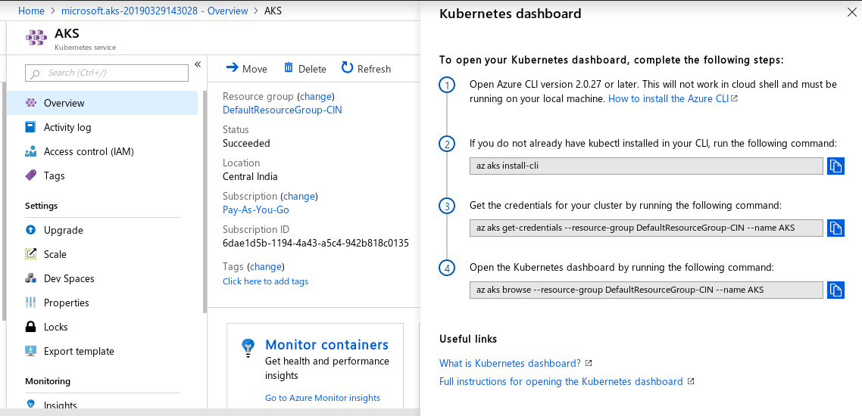

**1. Open a command prompt on the Windows laptop and terminal on mac laptops.**

**Installing az-cli on windows**

**2. Goto the below url**

[**https://docs.microsoft.com/en-us/cli/azure/install-azure-cli-windows?view=azure-cli-latest**](https://docs.microsoft.com/en-us/cli/azure/install-azure-cli-windows?view=azure-cli-latest)

**3. Download the MSI Installer and run it.**

1. Open your CMD
2. Run the login command.
3. Azure CLI.

4. On your command prompt run the below command.

|  |
| --- |
| az login |

1. If the CLI can open your default browser, it will do so and load a sign-in page.
2. Otherwise, you need to open a browser page and follow the instructions on the command line to enter an authorization code after navigating to<https://aka.ms/devicelogin> in your browser.
3. Sign in with your account credentials in the browser.

**5. After login in to your azure account, run the commands as mentioned in the Kubernetes Dashboard instructions as shown in the screenshot step-8.**

**6. Run the first command to install kubectl**

|  |
| --- |
| **az aks install-cli** |

**Note : Once you run the first command you need to export the kubectl path as shown in the instructions from your output of**

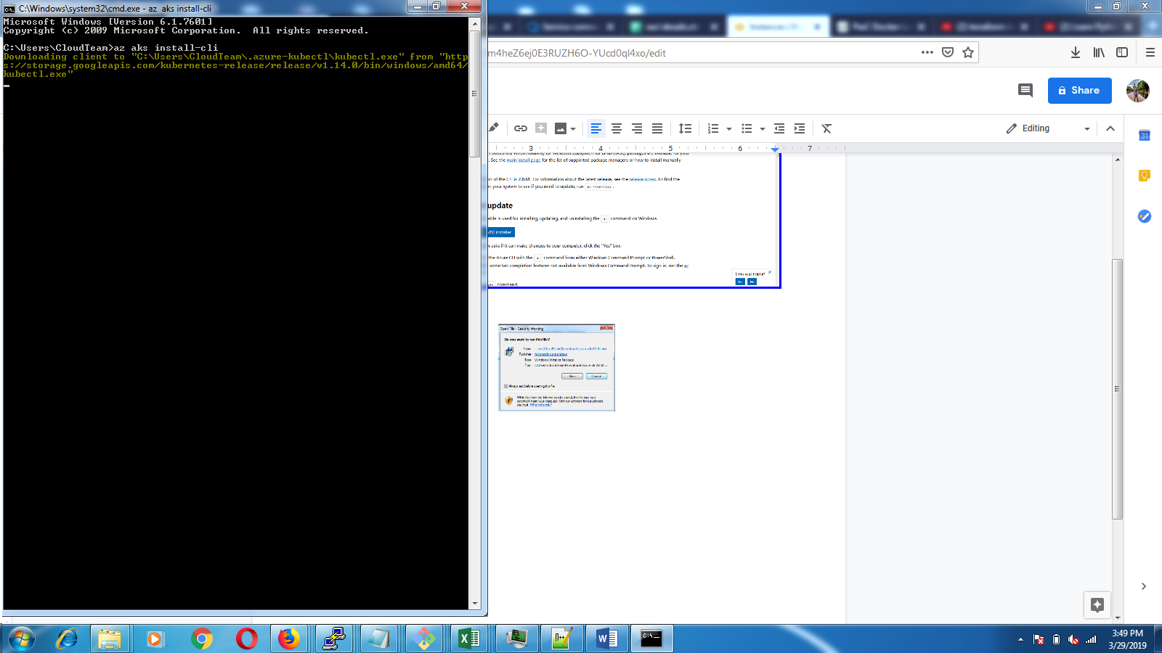

**Example**

**7. Update <user-name> in the below command as shown in the output from the above command.**

|  |
| --- |
| **> set PATH=%PATH%;C:\Users\<user-name>\.azure-kubectl** |

**8. Get the credentials for your cluster by running the following command: Update the --name AKS to the name of your cluster that you set during cluster initialization.**

|  |
| --- |
| **az aks get-credentials --resource-group DefaultResourceGroup-CIN --name AKS** |

**9. Run the below command to check if you are able to connect to the az aks from your local command prompt/terminal**

|  |
| --- |
| **kubectl get nodes** |

**10. Open the Kubernetes dashboard by running the following command: Update --name AKS with your Clustername**

|  |
| --- |
| **az aks browse --resource-group DefaultResourceGroup-CIN --name AKS** |

**Installing az-cli on MAC**

**11. If you do not have brew open the terminal and run the below command to install brew**

|  |
| --- |
| **/usr/bin/ruby -e "$(curl -fsSL https://raw.githubusercontent.com/Homebrew/install/master/install)"** |

**12. Now, install the azure-cli by running the below command**

|  |
| --- |
| **brew install azure-cli** |

**13. Once the az-cli is installed run the below command to login to your azure account**

|  |
| --- |
| **az login** |

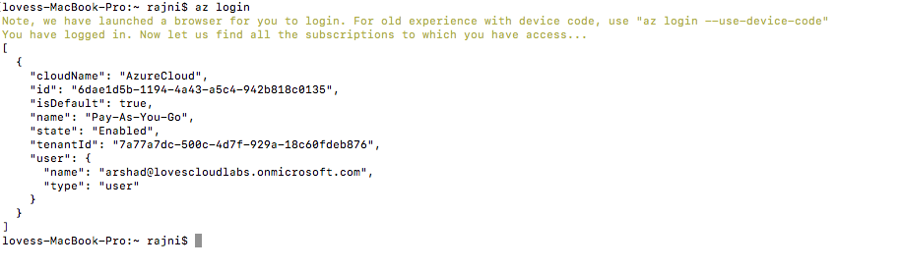

**14. After you login run the below command to install az aks cli**

|  |
| --- |
| **az aks install-cli** |

**15. Run the commands from step 17,18 & 19 from the mac terminal to get the kube config on your local terminal and open the dashboard.**

